**JustLee Books has become the exclusive distributor for a number of books. The company now needs to assign sales representatives to retail bookstores to handle the new distribution duties.**

For these assignments, create new tables to support the following:  
1. Modify the following SQL command so that the Rep_ID column is the PRIMARY KEY for the table and the default value of Y is assigned to the Comm column. (The Comm column indicates whether the sales representative earns commission.)

CREATE TABLE store_reps  
(rep_ID NUMBER(5) CONSTRAINT rep_pk PRIMARY KEY,  
last VARCHAR2(15),  
first VARCHAR2(10),  
comm CHAR(1) DEFAULT ‘Y’);

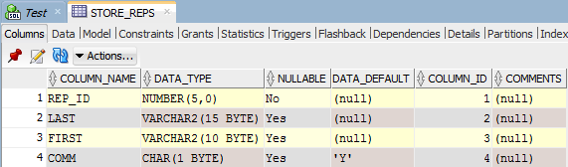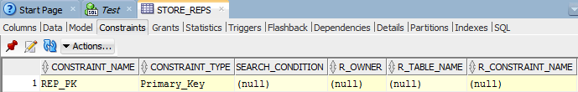 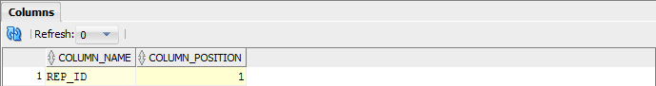

2. Change the STORE_REPS table so that NULL values can’t be entered in the name  
columns (First and Last).

ALTER TABLE store_reps

MODIFY (FIRST CONSTRAINT lname_nn NOT NULL);

ALTER TABLE store_reps

MODIFY (FIRST CONSTRAINT fname_nn NOT NULL)

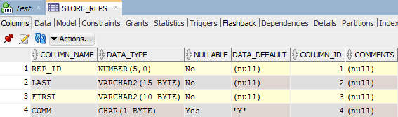

3. Change the STORE_REPS table so that only a Y or N can be entered in the Comm  
column.

ALTER TABLE store_reps

ADD CONSTRAINT comm_val CHECK (comm IN ('Y','N'));

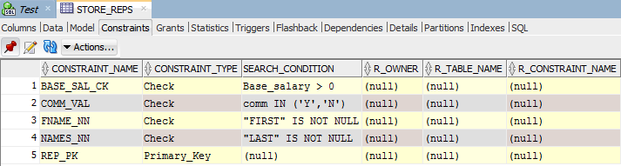

4. Add a column named Base_salary with a datatype of NUMBER(7,2) to the STORE_REPS table. Ensure that the amount entered is above zero.

ALTER TABLE store_reps

ADD Base_salary NUMBER (7,2);

ALTER TABLE store_reps

ADD CONSTRAINT base_sal_ck CHECK (Base_salary > 0);

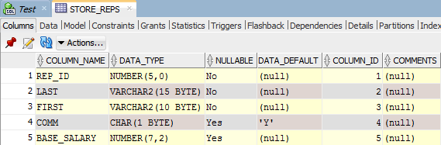

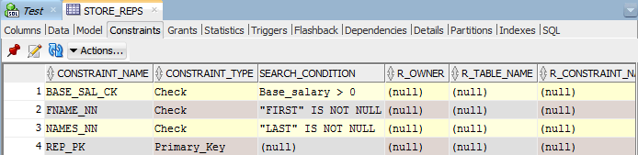

5. Create a table named BOOK_STORES to include the columns listed in the following chart.

CREATE TABLE book_stores

("Store_ID" NUMBER(8) CONSTRAINT store_pk PRIMARY KEY,

"Name" VARCHAR2(30),

"Contact" VARCHAR2(30),

"Rep_ID" VARCHAR2(5));

ALTER TABLE book_stores

ADD CONSTRAINT name_uk UNIQUE ("Contact");

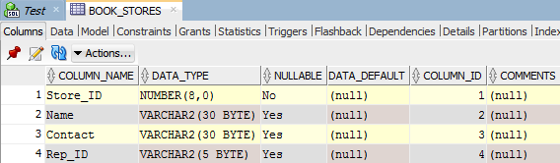

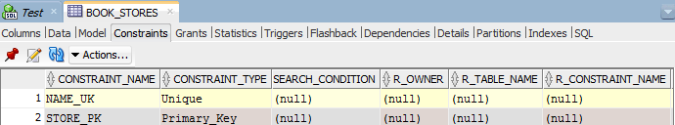

6. Add a constraint to make sure the Rep_ID value entered in the BOOK_STORES table is a valid value contained in the STORE_REPS table. The Rep_ID columns of both tables were initially created as different datatypes. Does this cause an error when adding the constraint? Make table modifications as needed so that you can add the required constraint.

|  |  |  |
| --- | --- | --- |
| **Column Name** | **Datatype** | **Constraint Comments** |
| Store_ID | NUMBER(8) | PRIMARY KEY column |
| Name | VARCHAR2(30) | Should be UNIQUE and NOT NULL |
| Contact | VARCHAR2(30) |  |
| Rep_ID | VARCHAR2(5) |  |

ALTER TABLE book_stores

MODIFY ("Rep_ID" NUMBER(5))

ADD CONSTRAINT book_stores_fk FOREIGN KEY ("Rep_ID")

REFERENCES "STORE_REPS" ("REP_ID");

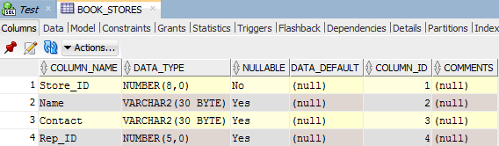

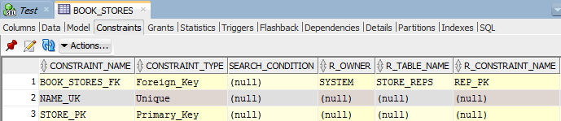

7. Change the constraint created in Assignment #6 so that associated rows of the  
BOOK_STORES table are deleted automatically if a row in the STORE_REPS table is  
deleted.

ALTER TABLE book_stores

DROP CONSTRAINT book_stores_fk;

ALTER TABLE book_stores

ADD CONSTRAINT book_stores_fk_del FOREIGN KEY("Rep_ID")

REFERENCES Store_Reps ("REP_ID") ON DELETE CASCADE;

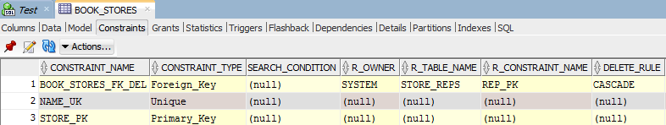

8. Create a table named REP_CONTRACTS containing the columns listed in the following chart. A composite PRIMARY KEY constraint including the Rep_ID, Store_ID, and Quarter columns should be assigned. In addition, FOREIGN KEY constraints should be assigned to both the Rep_ID and Store_ID columns.

|  |  |
| --- | --- |
| **Column Name** | **Datatype** |
| Store_ID | NUMBER(8) |
| Name | NUMBER(5) |
| Quarter | CHAR(3) |
| Rep_ID | NUMBER(5) |

CREATE TABLE rep_contracts

("Store_ID" NUMBER(8),

"Name" NUMBER(5),

"Quarter" CHAR(3),

"Rep_ID" NUMBER(5));

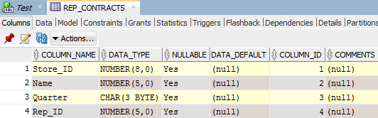

9. Produce a list of information about all existing constraints on the STORE_REPS table.

ALTER SELECT *

FROM user_constraints

WHERE table_name = 'STORE_REPS';

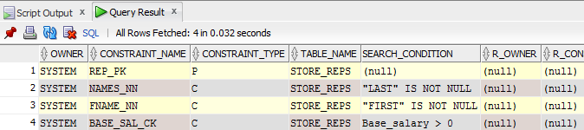

10. Issue the commands to disable and then enable the CHECK constraint on the

Base_salary column.

ALTER TABLE store_reps

DISABLE CONSTRAINT BASE_SAL_CK;

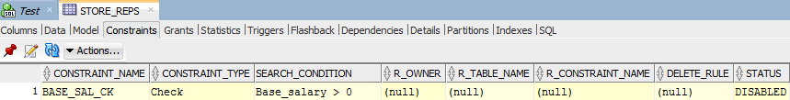

ALTER TABLE store_reps

ENABLE CONSTRAINT BASE_SAL_CK;

